RESUME
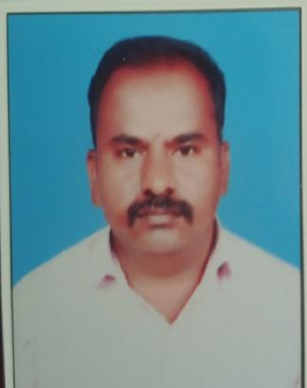
VADIVEL P
Assistant Professor in Computer Science,
Anugraha Institute of Social Sciences,
Dindigul – 624003
Contact: 9843947061
Email ID: vadicute@gmail.com

OBJECTIVE

To get a challenging position of lecturer in which I can utilize my hard work and make the bright carrier of students and seeking a career to share my knowledge and experience with students and gain more experience in the education and teaching field.
EDUCATIONAL QUALIFICATION

DEGREE/COURSE | COLLEGE/UNIVERSITY | YEAR OF PASS | PERCENTAGE
SSLC | Govt. High School  Eriyodu | 2000 | 55
HSC | Govt. Hr.Sec.School  Vedasandur | 2003 | 63
BCA | APA College Arts & Culture  Palani | 2006 | 58
MCA | Hindustan College of Engineering &Technology,Coimbatore | 2009 | 74

SOFTWARE PROFICIENCY

Languages : C, C++, JAVA,PYTHON,
Databases : ORACLE, MYSQL,MS ACCESS
Others : HTML,.NET,etc

SUBJECT HANDLED

Artificial Intelligence
ALL Languages
Multimedia
Data Structures and Algorithms
Software Engineering,Testing
DBMS,RDBMS
Computer Network
Operating System

AREA OF INTEREST

Artificial Intelligence and machine Learning
Cloud Computing
Computer networks and Network security
Data base Apllications

PROJECTS

PROJECT BRANCH (MCA): COLOR BLINDNESS(.NET & SQL server)

TEACHING EXPERIENCE
Sl. No | Institute / College | Department | Category | From – To (period)
1. | Amman College of Arts and Science, Dindigul. | Computer Science | Assistant Professor | 01. 06. 2011– 01.06.2020
2. | Anugraha Institute of Social Sciences, Dindigul. | Computer Science | Assistant Professor | 01.06.2024 – Till date

PARTICIPATED IN FACULTY DEVELOPMENT PROGRAM

1. | Innovative Teaching Strategies | One day FDP -2024 | Anugraha Institute of Social Sciences, Dindigul
2. | Effective usage of AI in Research with Hands on Experience | One day FDP -2025 | Anugraha Institute of Social Sciences, Dindigul

ORGANIZED/PARTICIPATED IN WOKSHOP AND SEMINAR

1. | Wirless mesh Networking | Participate in 2015 | Rev. Jaccob Arts & Science ,Ambilikai,Dindigul

EXPERIENCE

NSS PROGRAM OFFICER,AMMAN COLLEGE OF ARTS & SCIENCE,DINDIGUL.

TOTAL NO OF EXPERIENCE :SEVEN

PERSONAL SKILLS

Maintaining Unity among all, Self Motivated, Innovative, Hardworking and Dedicate, Good ability to work as a part of team and Good leadership quality.

PERSONAL DETAILS

Name : VADIVEL.P
Date of Birth : 29-05-1981
Gender : Male

Marital Status : Married
Residential Address : Puliyampatty,Chittur(po),Eriyodu(via),Vedasandur, Dindigul-624 702.
Languages Known : English and Tamil
BloodGroup :A1B+

Nationality : Indian
Religion : Hindhu
E-mail ID : vadicute@gmail.com
Mobile :9843947061

DECLARATION

I hereby declare that the statements made in this application are correct to the best of my knowledge.

Place : DINDIGUL Yours faithfully,
Date : P.VADIVEL

