**RESUME**

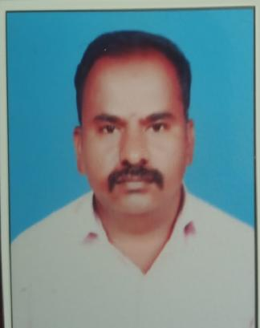  **VADIVEL P**

Assistant Professor in Computer Science,

Anugraha Institute of Social Sciences,

Dindigul – 624003

Contact: 9843947061

Email ID: vadicute@gmail.com

**OBJECTIVE**

# To get a challenging position of lecturer in which I can utilize my hard work and make the bright carrier of students and seeking a career to share my knowledge and experience with students and gain more experience in the education and teaching field.

**EDUCATIONAL QUALIFICATION**

|  |  |  |  |
| --- | --- | --- | --- |
| **DEGREE/COURSE** | **COLLEGE/UNIVERSITY** | **YEAR OF PASS** | **PERCENTAGE** |
| SSLC | Govt. High School  Eriyodu | 2000 | 55 |
| HSC | Govt. Hr.Sec.School  Vedasandur | 2003 | 63 |
| BCA | APA College Arts & Culture  Palani | 2006 | 58 |
| MCA | Hindustan College of Engineering &Technology,Coimbatore | 2009 | 74 |

**SOFTWARE PROFICIENCY**

Languages : C, C++, JAVA,PYTHON,

Databases : ORACLE, MYSQL,MS ACCESS

Others : HTML,.NET,etc

**SUBJECT HANDLED**

Artificial Intelligence

ALL Languages

Multimedia

Data Structures and Algorithms

Software Engineering,Testing

DBMS,RDBMS

Computer Network

Operating System

**AREA OF INTEREST**

Artificial Intelligence and machine Learning

Cloud Computing

Computer networks and Network security

Data base Apllications

**PROJECTS**

**PROJECT BRANCH (MCA):** COLOR BLINDNESS(.NET & SQL server)

**TEACHING EXPERIENCE**

|  |  |  |  |  |
| --- | --- | --- | --- | --- |
| **Sl. No** | **Institute / College** | **Department** | **Category** | **From – To (period)** |
| 1. | Amman College of Arts and Science, Dindigul. | Computer Science | Assistant Professor | 01. 06. 2011– 01.06.2020 |
| 2. | Anugraha Institute of Social Sciences, Dindigul. | Computer Science | Assistant Professor | 01.06.2024 – Till date |

**PARTICIPATED IN FACULTY DEVELOPMENT PROGRAM**

|  |  |  |  |
| --- | --- | --- | --- |
| 1. | Innovative Teaching Strategies | One day FDP -2024 | Anugraha Institute of Social Sciences, Dindigul |
| 2. | Effective usage of AI in Research with Hands on Experience | One day FDP -2025 | Anugraha Institute of Social Sciences, Dindigul |

**ORGANIZED/PARTICIPATED IN WOKSHOP AND SEMINAR**

|  |  |  |  |
| --- | --- | --- | --- |
| 1. | Wirless mesh Networking | Participate in 2015 | Rev. Jaccob Arts & Science ,Ambilikai,Dindigul |

**EXPERIENCE**

NSS PROGRAM OFFICER,AMMAN COLLEGE OF ARTS & SCIENCE,DINDIGUL.

TOTAL NO OF EXPERIENCE :SEVEN

**PERSONAL SKILLS**

Maintaining Unity among all, Self Motivated, Innovative, Hardworking and Dedicate, Good ability to work as a part of team and Good leadership quality.

**PERSONAL DETAILS**

Name : VADIVEL.P

Date of Birth : 29-05-1981

Gender : Male

Marital Status : Married

Residential Address : Puliyampatty,Chittur(po),Eriyodu(via),Vedasandur, Dindigul-624 702.

Languages Known : English and Tamil

BloodGroup :A1B+

Nationality : Indian

Religion : Hindhu

E-mail ID : [vadicute@gmail.com](mailto:sweetjohnsy93@gmail.com)

Mobile :9843947061

**DECLARATION**

I hereby declare that the statements made in this application are correct to the best of my knowledge.

**Place : DINDIGUL Yours faithfully,**

**Date : P.VADIVEL**