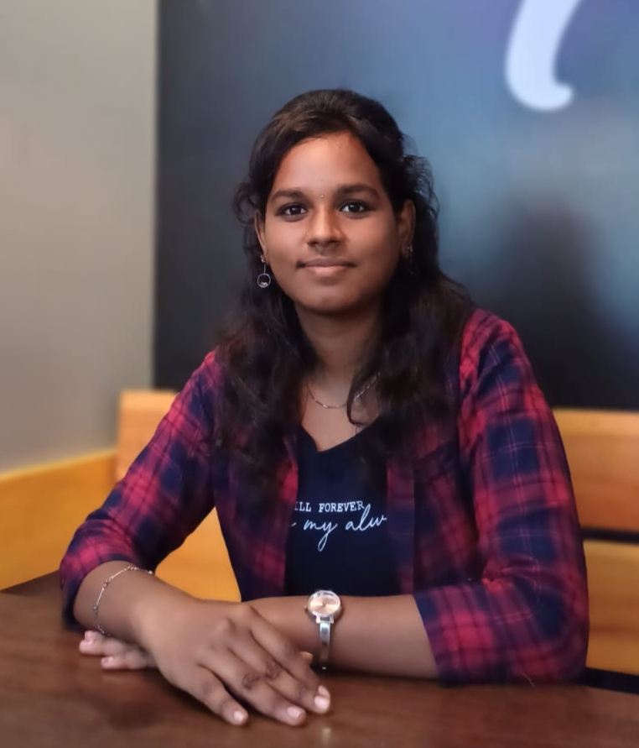 **SELVAMEENA .C**

**Assistant Professor**

**Department of Visual Communication**

Passionate about teaching and media analysis, Academic & Research Journalism Skills in a dynamic media environment.

Contact : 6374228764, [Selvameena9092@gmail.com](mailto:Selvameena9092@gmail.com) , Madurai, TamilNadu, India

**EDUCATION QUALIFICATION**

|  |  |  |  |
| --- | --- | --- | --- |
| **DEGREE** | **COURSE** | **NAME OF BOARD** | **YEAR** |
| MA | Journalism and mass communication | Madurai Kamaraj University | 2022-2024 |
| BA | English literature | N.M.S. Sermathai Vasan College for Women | 2018-2021 |
| Diploma | Gandhian Thought | Madurai Kamaraj University | 2019-2020 |
| Diploma | Communicative and Functional English | Madurai Kamaraj University | 2018-2019 |
| HSC | Bio-Maths | Sri Meenakshi Sundareswarar girls Higher Secondary School | 2017-2018 |

**AREA OF SPECIALIZATION**

* Mass communication
* Broadcast Journalism
* Advertising & Marketing
* Documentary film making
* Anchoring presentation
* New Media (Blog & Podcast)

**PROFESSIONAL WORK HISTORY**

**Anugraha Institute of Social Sciences (Present) (June 2024)**

* I am working in Assistant Professor Department of visual communication,
* I take classes for both UG & PG
* Teaching & Academic Related work
* Naan Mudhalvan Coordinator

**SOCIAL MEDIA EXECUTIVE (THE COMPASS TAMIL) (April 2024)**

* I am working as digital media content writer & video Presenter/ Anchor.

**INTERNSHIP TRAINEE**

**TELEVISION MEDIA NEWS INTERNSHIP (January 2024)**

**News Tamil 24x7, Chennai**

* I learned about News production and Post Production skills in Broadcast Journalism.

**TAMIL FILM INDUSTRY INTERNSHIP (December 2023)**

**Bicstol Mart Production, Chennai**

* I worked as a Assistant Film director of Pre- production work for Tune Movie

**PRINT MEDIA NEWS INTERNSHIP (June 2023)**

**Theekathir News Paper, Madurai**

* In Theekathir Internship , I learned News Gathering , Reporting, Script Writing , and News Publishing for Print Media.

**SIGNATURE STRENGTH (SKILLS)**

* Critical Thinking
* Communication
* Media Literacy
* Research
* Interpersonal

**SOFTWARE KNOWLEDGE**

* Adobe premier Pro
* Adobe photoshop
* AI-Research tool

**NATIONAL CONFERENCE PAPER PRESENTED**

* Portrayal of Women in Tamil Top Channel Advertisements presented a paper at St Joseph College of Communication, Kerala **(February 2025)**

**INVITED LECTURE**

* I Conducted a One day Seminar on Film Appreciation, at Department of Computer Science and Engineering, MAMCET, Trichy on 08.11.2024.

**TRAINING PROGRAM ATTENDED**

* I attend the Naan Mudhalvan Faculty Development programme (Digital Marketing). ( June 2024)
* I acted as University External Examiner for Naan Mudhalvan University Examination held on 5th October 2024 at the Athoor Cooperative Arts & Science College.
* I acted as University External Examiner for Naan Mudhalvan University Examination held on 21st October 2024 at Rama Prabha Arts & Science College.
* I attend the Trainig Program on SPSS at Anugraha Institute of Social Sciences.
* I attend the NEP 2020 Orientation & Sensitization Programme Organized by UGC Malviya Mission Teacher Training Programme.
* I attend the Faculty Development Programme (Effective Usage of AI in Research with hands on Experience) at Anugraha Institute of Social Sciences.
* I attend the Naan Mudhalvan Faculty Development programme (Career Readiness Program). (Jan 2025)

**WORKSHOP & CERTIFICATES**

* I attend the One day National Level Seminar On ‘Artificial Intelligence and Media’
* I attend the News Production Skills Workshop at Madurai Kamaraj university.
* I attend a Prakriti International National Documentry film festival Workshop at Madurai kamaraj University.
* Skill Development course International English Language testing system at Madurai Kamaraj University.
* I Participated in the one day National Level Workshop on Aesthetic & Appropriate Facets to Learn Part-II English at NMS. Sermathai Vasan College for women.

**KEY ACHIEVEMENT**

* Nehru Yuva Kendra – District level Youth Festival & Science Mela Invite Event Judge for Mobile Photography.
* Fencing Player - Tamil Nadu State & District Level Competition.